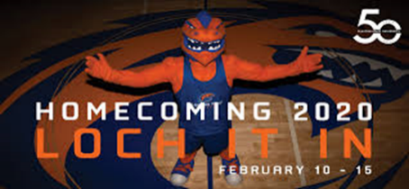
2020 Homecoming King and Queen
Candidate Verification Form

All interested candidates should complete the Homecoming Court online application as well as print, complete, and submit this Verification Form.

Candidate Full Name:

Laker ID#:

Applying for (Circle One):
(Refer to position/candidate eligibility requirements in the
Eligibility and Information Packet.)

Homecoming King Homecoming Queen
(Please checkmark each statement.)
- I attest that I am the above named person and am submitting my application for Homecoming King and Queen Election. I further attest that the information I have provided regarding my candidacy is accurate and complete to the best of my knowledge.

- I give permission to the Dean of Students Office to verify all information contained in my on-line application, including my Cumulative Grade Point Average and Earned Credit Hours.

- Finally, I agree to allow publication of my name and photo as a part of any on-line or print homecoming marketing materials.

_________________________________________________________ ______________________

Signature Date

*OPTIONAL* Organization Sponsorship
Candidates have the opportunity to be sponsored by an organization. Below please provide name of the organization (if applicable) as well as provide the signature of the president and faculty advisor.

Organization Sponsorship:

Signature of President Date
Of Organization

Signature of Faculty Advisor Date
Of Organization

Return this form IN PERSON and present valid Laker ID Card to:
Office of the VP for Student Affairs
University Center, room 250
DEADLINE: FRIDAY, JANUARY 31, 2020, 12:00 p.m.
Office use only:
IDCK: | INIT: | DTRCD:

