Dual Enrollment Course Material Instructions
Summer 2020
Step One:
Verify that the University has your correct mailing address. You can do this by logging into the Duck, clicking Personal Information, and then clicking View Addresses and Phones. From here, you can click Update Addresses and Phones if you need to make changes.
Access the Duck: https://selfservice.clayton.edu/login
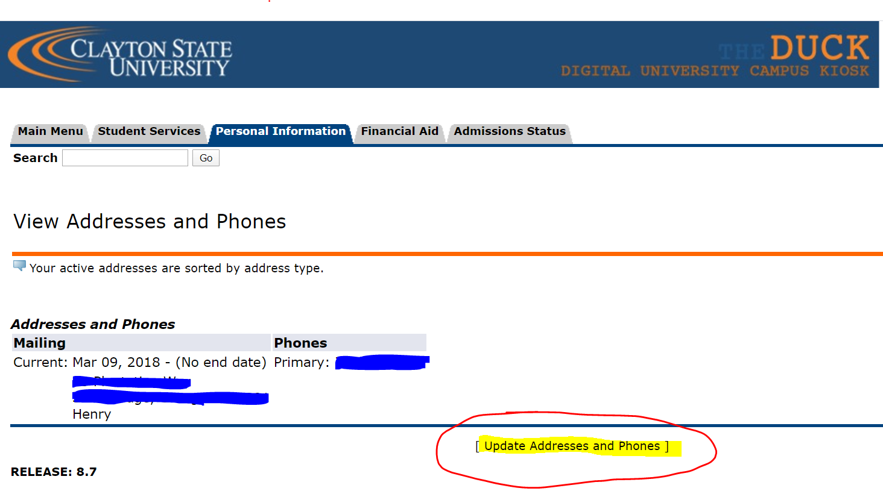
Step Two:
Complete and return the Dual Enrollment Loan Agreement. You can email the signed agreement to the Loch Shop at sm8307@bncollege.com.
The DE Loan Agreement Form and a DE Frequently Asked Questions page can be found at https://www.clayton.edu/auxservices/the-loch-shop/.
Please complete Steps One and Two no later than May 11th, 2020.
Step Three:
Beginning May 11, check your Clayton State email account for an order confirmation for your course materials. Verify that the materials ordered match your course schedule. You can find your course schedule by logging into The Duck and clicking Student Services, then click Registration, then choose the option for Student Schedule.
If you need to make changes to your course materials order, please contact the Loch Shop at sm8307@bncollege.com.
Step Four:
Check your Clayton State email account for a shipping confirmation. Digital codes and physical textbooks will be mailed to your home mailing address. E-books will be emailed to your Clayton State email account.
Step Five:
Check your Clayton State email account for any E-books you may receive. Check you Junk folder if you do not find it in your Inbox.
Physical books and digital codes will be mailed to your mailing address so it is important that the University has your current mailing address on record.
If you do not receive your codes or books within 10 days of receiving your shipping confirmation, please contact the Loch Shop at sm8307@bncollege.com.
**Special Note about dropping classes: If you drop a class after the start of the semester, you will need to return the book to the Loch Shop within one week of dropping the class. You may do so by either (1) shipping the book back to the store at your own expense or (2) contacting the Loch Shop to schedule a time to drop the book in a secure location.
**Special Note about adding classes: If you add a class after the start of the semester, it will be your responsibility to email the Loch Shop to notify them of your change in schedule. You may email the store at sm8307@bncollege.com.
Step Six:
You will receive a rental return reminder email towards the end of summer semester which will include instructions on how to return your physical books via UPS. You can also find instructions and more information regarding rental returns at https://lochshop.bncollege.com/shop/clayton/page/rental-book-return.

