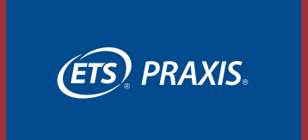

What is it?

The Praxis Core Academic Skills for Educators: Writing (5723) assesses both argumentative writing and informative/ explanatory writing and will contain two writing tasks for each writing type. In addition, selected-response questions will be added to address the importance of research strategies and assess strategies for revising and improving text. Passing score of 162 or higher.

How much is the cost?
$90

Who must take the Test?
New applicants that were not admitted to the Elementary Education program prior to January 1, 2023, will be required to pass the Praxis Core Academic Skills Writing test, unless you qualify to exempt the test.

Exemptions
Candidates who meet the following scores do not have to take the Praxis Core Academic Skills for Educators Writing Test
* SAT: min score 1,000 (Crit. Reading + Math), ACT: min score 43 (English + Math) if you took the test before July 2019 or if you took the test After July 2019, exempt requirements min score 1,080 (Crit. Reading + Math), ACT: min score 43 (English + Math)

Test Delivery Method

Praxis tests are delivered on computer and are offered throughout the year.
Following images and information from: https://www.ets.org/pdfs/praxis/5723.pdf and https://www.ets.org/praxis/site.html

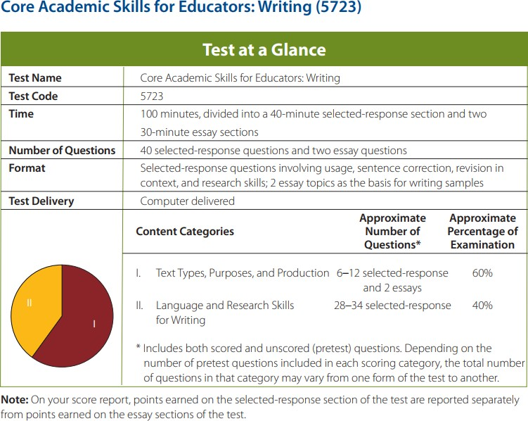
View the online Study Companion https://www.ets.org/pdfs/praxis/5 723.pdf for your test for details.

Visit www.ets.org/praxis/register/date s_centers to learn when your test is offered.

Contact Information

