Current Policy:

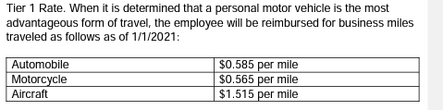

Change to:

Tier 1 Rate. When it is determined that a personal motor vehicle is the most advantageous form of travel, the employee will be reimbursed for business miles traveled as follows as of 7/1/2022:

|  |  |
| --- | --- |
| Automobile | $0.625 per mile |
| Motorcycle | $0.565 per mile |
| Aircraft | $1.515 per mile |

Current Policy:

What is the current mileage rate?

As of January 1, 2022, for automobiles, the Tier 1 mileage rate is $0.585 and the Tier 2 rate is $0.18, for motorcycles, the mileage rate is $0.565 and for airplanes the mileage rate is $1.515. Please see, should I use a rental vehicle or a personal vehicle?

Change to:

***What is the current mileage rate?***

As of July 1, 2022, for automobiles, the Tier 1 mileage rate is $0.625 and the Tier 2 rate is $0.18, for motorcycles, the mileage rate is $0.565 and for airplanes the mileage rate is $1.515. Please see, should I use a rental vehicle or a personal vehicle?