Bike Commuting Tips

Why commute by bike?
Atlanta is ranked top 50 for most bike-friendly cities in the United States for 2016. Additionally, bike commuting has a number of benefits that will likely enrich your life and the world around you:
- Environment: According to the EPA, the average passenger car emits 4.7 metric tons of carbon dioxide every year. Biking more and driving less is a great way to reduce your carbon footprint. Bicycle travel saves over 3,000,000 metric tons of carbon dioxide per year.
- Health: The CDC recommends that adults get at least 150 minutes of moderate-intensity exercise per week. By biking you can get the exercise you need, get to school or work, and save time by doing two things at once.
- Well-being: Portland State University found in a study of commute happiness that bicycle commuters had the highest level of “commute well-being”, followed closely by walking. Additionally, an analysis of the American Community Survey shows a positive association between percentage of bike commuters in a city and levels of happiness and well-being.
- Money: Purchasing and owning a car is quite expensive compared with biking. According to an annual report by AAA the average operating cost of an average sedan is $8698. On the other hand the average operating cost of a bike, as reported by the Sierra Club, is $308.

Commuter Tips!
Safety
- Helmets- Helmets have been estimated to reduce the odds of head injury by 50 percent, and the odds of head, face, or neck injury by 33 percent. To get the benefits of wearing a helmet it needs to be worn properly: low, level and snug. 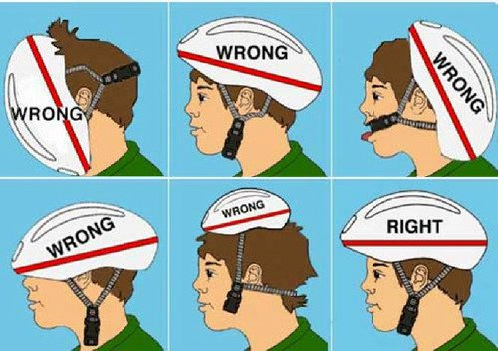
- Lights- Lights help you see and be seen, and they are required by law between sunset and sunrise. A good light is bright enough that you can see at least a few feet in front of you, look for something that has at least 200 lumens. Other features to look for are recharge ability and long battery life.

- Security
  - Locks- The three most important things you can do to prevent your bike from being stolen are use a good lock, lock your bike properly, and ride your bike often. We highly recommend the use of a high quality u lock. Cable locks can be cut through in a few second with bolt cutter, whereas a u lock requires power tools or a lot of time to break.
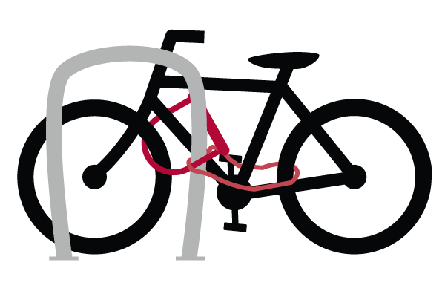
  - How to lock up your bike- When locking up your bike make sure you lock the frame and one of the wheels to the rack. If you only lock the wheel to the rack a thief can easily remove your wheel and walk off with the rest of your bike. If you only lock up the front wheel you could come back to your bike to see this:
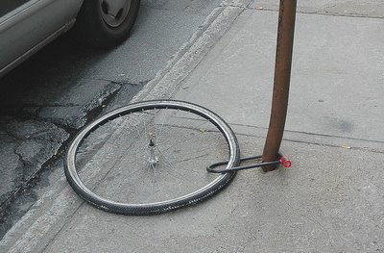

For added security add a cable lock to secure your wheels.
- Locking hardware/skewers- If you are concerned about the security of your wheels or components consider buying locking quick release skewers for your wheels and security bolts. Both of these require special tools and will keep thieves from being able to steal your gear. Having locking skewers and security hardware also deters theft of the whole bike in addition to protecting your components.
- Comfort
  - Picking the right bike for you- There are many styles of bike that make a good commuter: road bike, hybrid, rigid mountain bike, single speeds, etc. However, perhaps the most important thing to consider when choosing a commuter is finding a bike that fits. The right place to start is to get a good idea of what size you need by measuring your inseam and then refer to a bike sizing chart which can be found online. When you are out shopping for a bike first make sure you can sand over the bike. However you want a bike that is large enough that the saddle can be at the right position so you are getting close to full extension while pedaling (25-35 degree bend). You also want to pay attention to the position of your torso and arms, there should be about 90 degree angle between the two. These are just a few basic things to look at when finding a bike for you, visit a local bike shop to get some expert and individualized help finding the right bike for you.
  - Clothing- Special clothing is not required to commute by bike, but it is a good idea to wear clothing that allows you to move freely and is breathable. Remember that you will likely warm up as you are riding so don’t overdress, and in Georgia it is good to be prepared for the weather to change. Wearing sturdy, closed-toe shoes that grip your pedal and protect your feet is highly recommended.

