How to: Access PeopleSoft and GeorgiaFirst Marketplace

In your desired web brower paste https://www.usg.edu/gafirst-fin/ or click on the blue underlined link. Your screen should resemble the below screen.

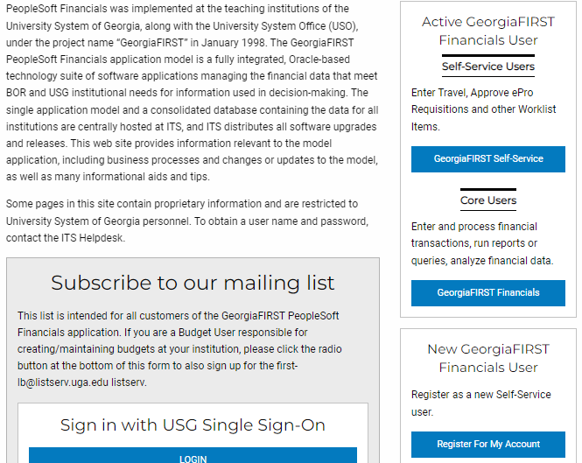

Go to the “Core Users” section and click on GeorgiaFirst Financials (Blue Highlighted Box)

On the PeopleSoft Financials login page, enter your User ID and Password. Remember, both of these items are case sensitive. If you try to log in more than five times with an incorrect User ID and/or password, the system will lock you out.

Click the Sign In button.

Your screen will resemble the below screen. If not, please contact the Procurement Office and we will help you set a GFM Shopper Access tile on your main screen.

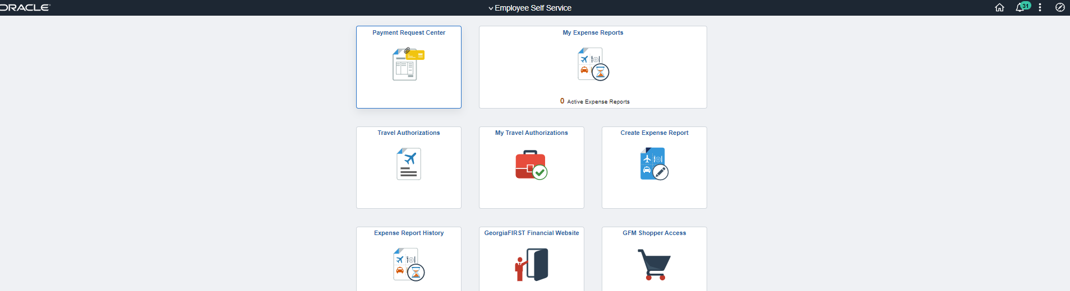

Select GFM Shopper Access Tile.

Your Current Page should resemble the below screen.

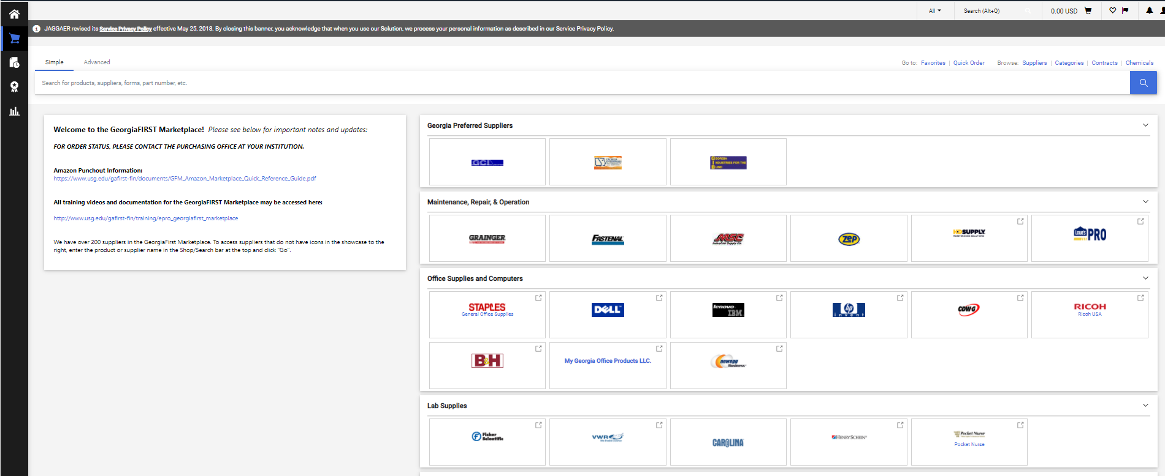
- When you are on the GeorgiaFirst Marketplace Home Screen you have many search options. Each search option is based upon your personal, shopping preference with GeorgiaFirst Marketplace Suppliers. Please go to the below, applicable sections to view guidance on how to search for your needed products.
  - How to: Perform a Simple Search
  - How to: Perform an Advanced Search
  - How to: Search from a Showcased Supplier

How To: Perform a Simple Search
- Start from the GeorgiaFIRST Marketplace home/shop page.
- In the search area you can choose either Simple or Advanced. Please see the below example.
- If you select Simple search, enter the item that you would like to search. Below is an example of where we searched for blue pens.
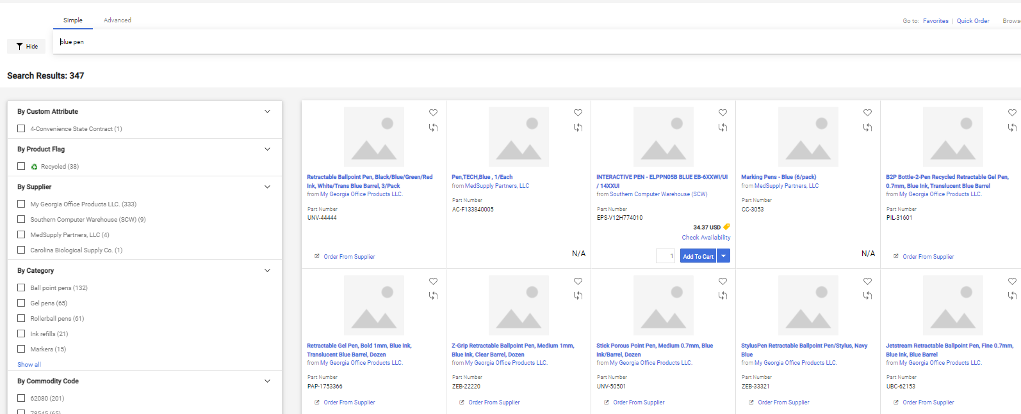
- If you desire to search by Advanced Search, please choose the Advanced section and create your search criteria. Below is a screenshot of how your Advanced, search section should look.
- Enter one or more keywords.
- Press the Search button.

How To: Perform an Advanced Search
- On the GeorgiaFIRST Marketplace home/shop page, select the advanced search link.
- Select a Product Category in the Advanced Search drop down list.
- In the Find Results That Have: section, use one or more of the following options:
  - All of These Words
  - Supplier
  - Part Number (SKU)
  - Manufacturer Name
  - CAS No. (Laboratory Supplies Category only)
  - Product Class (Laboratory Supplies Category only)
  - Product Size (Laboratory Supplies Category only)
- In the Other Options: section, use these additional fields as necessary:
  - Exact Phrase
  - Exclude Words
  - Any of the Words
- To search for items for a particular contract type, select the checkbox next to the appropriate
custom attribute/contract type.
  - For example, initially perform the search with Mandatory State Contract selected. If the search does not return the required item, repeat the search with Agency Contract selected.
- Click the Search button
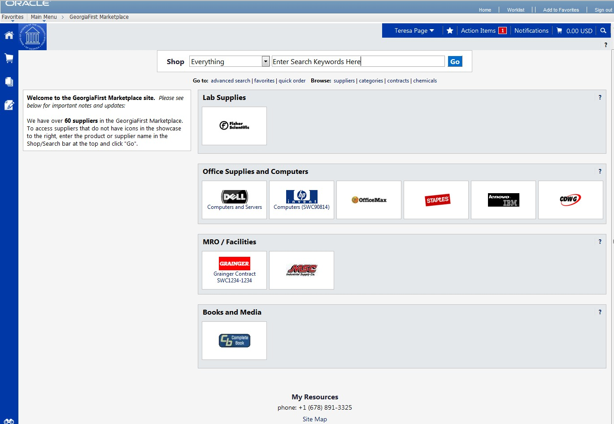

How To: Search from a Showcased Supplier
- From the GeorgiaFIRST Marketplace home/shop page, click on the Supplier name or icon in the Showcased Suppliers section. A pop-up displays that indicates how you can shop from the supplier. The options include a simple search. Depending on the system configuration, search by contract type may be available for some suppliers.
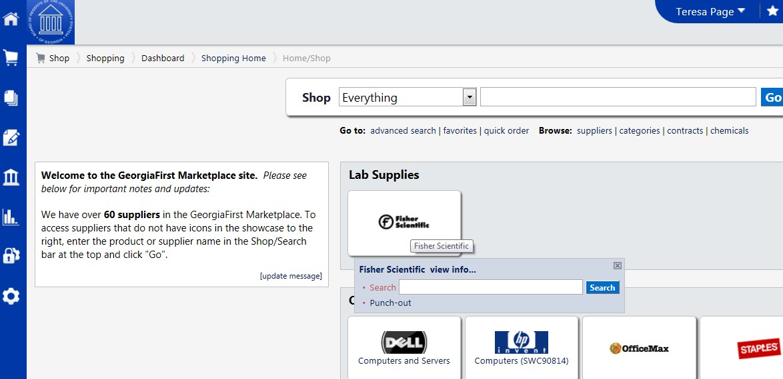

- Enter keywords in the Search field and click the Search button.
- The Search Results will appear and be formatted just how Simple Search and Advanced Search displays.
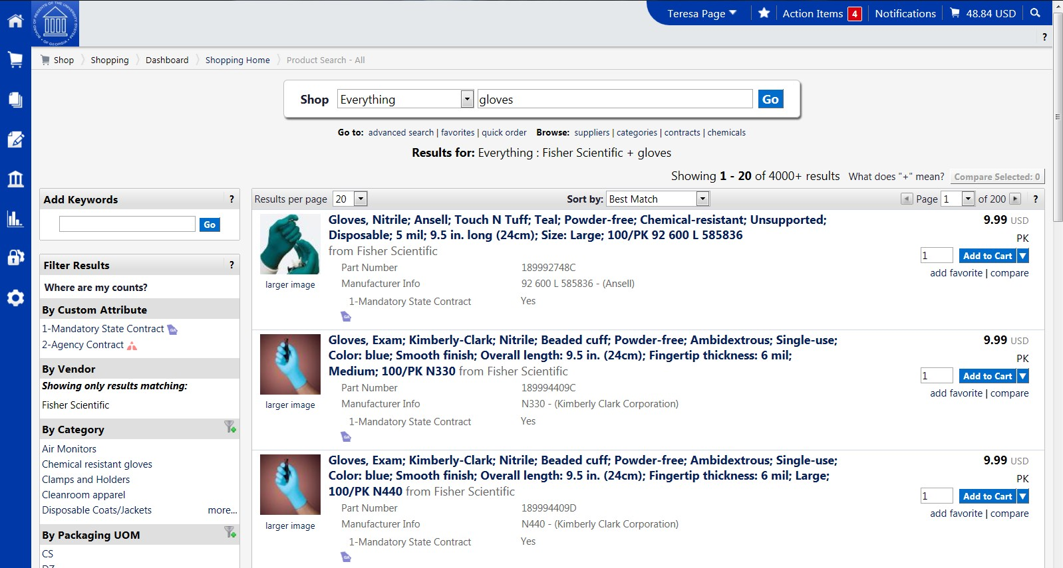

- From these search results, you can narrow down your results by using filter options, re-sorting the results, or adding additional keywords.

How To: Delete a Shopping Cart
- Select the Shopping Cart icon.
- Select the My Carts and Orders sub-link.
- Select the View Draft Shopping Carts sub link.
- Locate the cart you want to delete.
  - Your current (or active) cart will have an icon with a colored background.
  - Draft carts have an icon with a white background.
- Press the Delete button on the right side of the screen.
- After selecting Delete, the system deletes the cart immediately. Once a cart is deleted it is permanently removed and it cannot be restored.

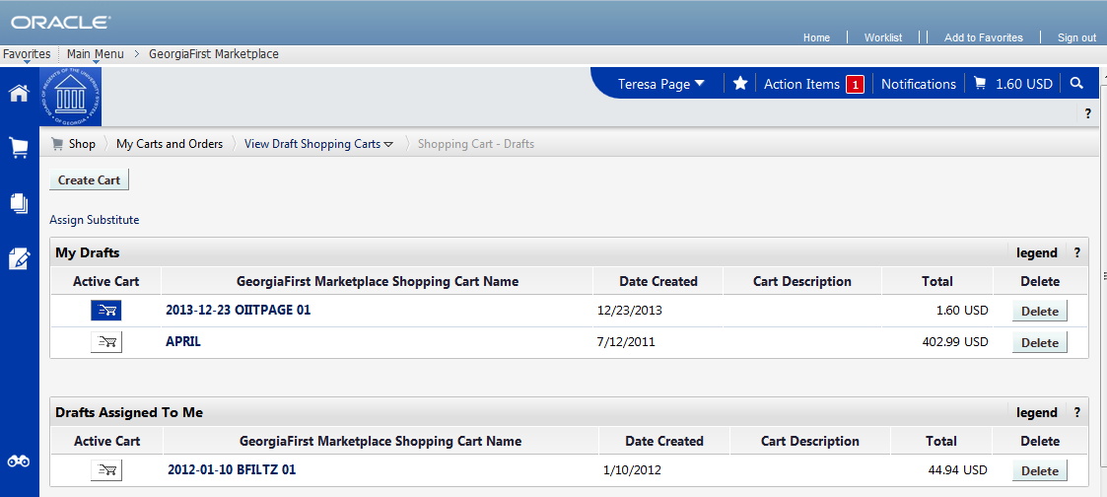

How To: Assign a Cart
- Pull up your shopping cart.
- Review your shopping cart to ensure that everything is correct. Make any necessary updates to the items in your cart.
- Select the Proceed to Checkout button.
- Here you perform a final review of your shopping cart. If you need to make any updates, you can select the appropriate edit button and make changes. You can also select the Return to shopping cart link in the upper right corner of the page.
- If you want to add any notes or comments, click the Comments tab.
  - Click the Add Comment button.
  - Enter your comment regarding the Chartfields. Keep in mind there is a 1000 character limit here.
  - Do not include any slashes (/) in your comments.
  - Click the Add Comment button.
  - Note: These comments are available to the Requester, but they are not included in the email notification.
- When you are ready to assign your cart, click the Assign Cart button.
- If you have a Default Requester in your profile, that Requester’s name should appear next to “Assign Cart To:”.
  - If you want to assign your cart to another Requester set up in your User Profile, select the “Search from profile values” link.
    - Using the drop down list, select the appropriate Requester.
  - If you do not have a Default Requester in your profile and need to search for your requester, select the “Search for an assignee” link.
    - In the User Search box, confirm your Business Unit appears in the Business Unit drop down list.
    - If you want to refine your search by department, select your Department in the drop down list.
    - Click the Search button.
    - Select the Requester you want to assign your shopping cart to and click the
Choose Selected User button.
- In the Note to Assignee section, enter any instructions about charging Chartfields that are not your default. This note is included in the email notification to the Requester.
- Click the Assign button. A shopping cart notification displays. Your shopping cart has now been assigned to your Requester.

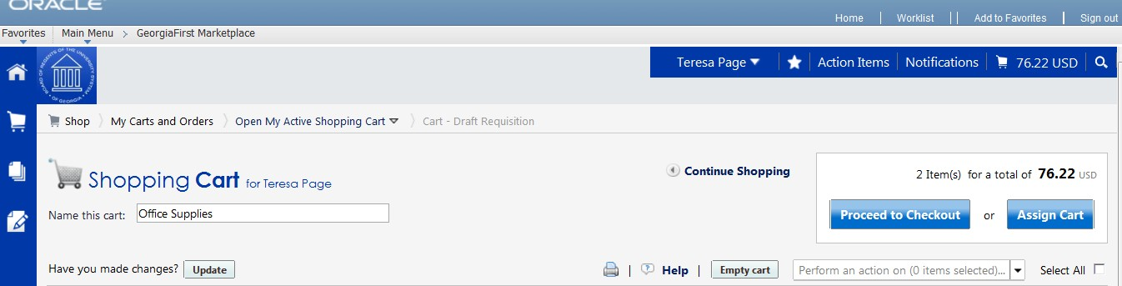
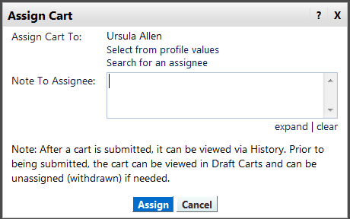
11.

- 10.

How To: Un-Assign a Cart
- From the GeorgiaFIRST Marketplace home page, select the Shopping Cart icon.
- Select the My Carts and Orders link.
- Select the View Draft Shopping Carts link.
- Locate the cart you want to un-assign under the section “My Drafts Assigned to Others” and click the Unassign button.
- Edit your cart as needed and then reassign it back to your Requester.
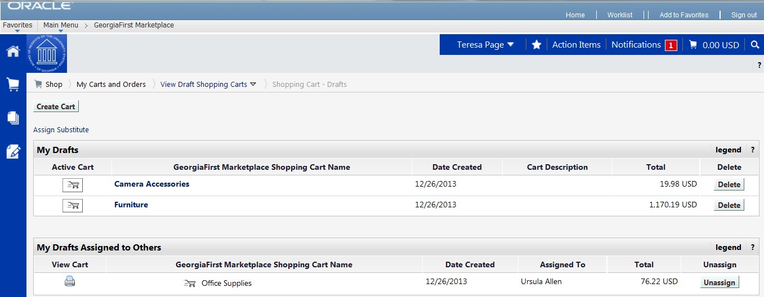

How To: Create a Basic Marketplace Requisition from an Assigned Shopping Cart
- Log into PeopleSoft Financials Core System.
- In the menu, select eProcurement.
- Select Requisition.
- Select the GAFIRST Marketplace link.
- In the GeorgiaFIRST Marketplace, select the Shopping Cart icon.
- Select the My Carts and Orders link.
- Select the View Draft Shopping Carts link.
- Under the Drafts Assigned to Me section, click on a cart to activate it.
- Review the shopping cart and perform any necessary edits.
- Select the Proceed to Checkout button.
- Select the Issue Requisition button.
- Confirm the Requisition Summary has the same number of line items as the requisition.
- On the Check Out – Review and Submit page, insert the Shopper’s User ID in the Requester
field.
- Name the requisition by populating the Requisition Name field if desired.
- For each requisition line item, edit Chartfields, Ship To Location, and Asset information if necessary.
- Add a comment on each requisition line if needed by clicking the “call out” (comment) icon at the end of the line.
- Add a header comment to be attached to the requisition if needed, using the Justification/Comments section. Do not include any slashes (/) in your comments.
- Click the Save for Later button and the Preview Approvals link.
- Review the approval path.
- Click the Submit button to route the requisition for approval.

How To: Review Line Item History
- In order to review line item history, you must first add the item to your cart.
- Access your shopping cart.
- For the item you want to review history for, select the More Actions drop down list.
- Select Line Item History and then click Go.
- The Line Item History pop-up box appears.
  - Previous Purchases Found: An item having previous purchases that fall within the search criteria will display the item’s description and details regarding those previous purchases, including quantity, date, User ID, and User email address.
  - No Previous Purchases Found: An item having no previous purchases meeting the
organization’s timeframe, department, and custom field criteria (if any) will display the item’s description and a message that no items were found.

How To: Charge a Requisition Line Item to a Different Chartstring
- When you have pulled the GeorgiaFIRST Marketplace shopping cart into an eProcurement requisition, you are returned to the Checkout - Review and Submit page.
- Expand the line you want to modify by clicking on its Expand Section button.
- Locate the Accounting Lines section.
- Go to the Chartfields 2 tab to update the following if needed:
  - Account
  - Fund Code
  - Department
  - Program
  - Class
- Go to the Chartfields 3 tab to update the following if needed:
  - Project
- Make other necessary changes and then continue with the Marketplace Requisition by selecting the Save & Submit button.
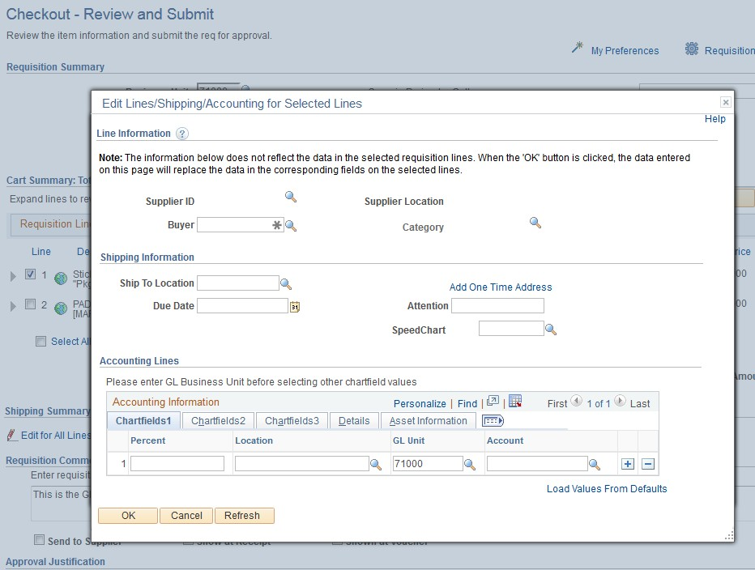

How To: Charge Multiple Requisition Line Items to a Different Chartstring GFM
- When you have pulled the GeorgiaFIRST Marketplace shopping cart into an eProcurement requisition, you are returned to the Checkout - Review and Submit page.
- Select the lines you want to change distribution information for by placing a checkmark in their
select boxes.
- Select the Mass Change button.
- In the Accounting Information section, enter the GL Unit (your business unit), then select the Chartfields 2 tab and enter the new Chartfields Values, then click Apply.
- On the Distribution Change Options, to apply changes to all selected lines, select the option “All Distribution Lines” and click OK.
- Make any other necessary changes and then continue with the Marketplace Requisition by selecting the Save & Submit button.
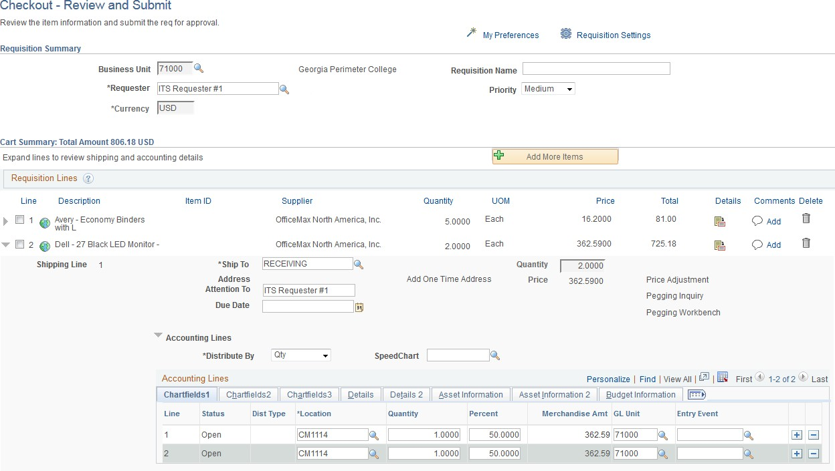

How To: Split Distribution for a Requisition Line
- When you have pulled the GeorgiaFIRST Marketplace shopping cart into an eProcurement requisition, you will be returned to the Checkout - Review and Submit page.
- Expand the line by clicking on its Expand Section button.
- Choose whether to Distribute by Amount or Quantity through the drop down list.
- Locate the Accounting Lines section.
- At the end of the line under the Chartfields1 tab, click the Add a New Row button (+).
- If distributing by Quantity, continue. If distributing by Amount, go to step 7.
  - In the original distribution line, edit the quantity for the revised distribution.
  - Tab out of the Quantity field. The Percent field should adjust accordingly.
  - In the new distribution line, enter the quantity for the second Chartstring.
  - Tab out of the Quantity field. The Percent field will adjust accordingly.
  - Make the necessary changes to the second string of Chartfields on the Chartfields 1, Chartfields 2, and Chartfields 3 tabs.
- If distributing by Amount, continue. Otherwise, go to step 8.
  - In the original distribution line, edit the amount for the revised distribution.
  - Tab out of the Amount field. The Percent field should adjust accordingly.
  - In the new distribution line, enter the amount for the second Chartstring.
  - Tab out of the Amount field. The Percent field will adjust accordingly.
  - Make the necessary changes to the second string of Chartfields on the Chartfields 1, Chartfields 2, and Chartfields 3 tabs.
- Make any other necessary changes and then continue with the Marketplace Requisition by selecting the Save and Preview Approvals button.

How To: Create a Special Request Requisition
- In PeopleSoft Financials Core System, select eProcurement from the menu.
- Select Requisitions.
- Select Special Requests
- To enter Requisition Defaults, click the Requisition Settings link. Otherwise, go to step 4.
  - If desired, enter a name for your requisition (if left blank, the Requisition ID will be listed here after saving).
  - Expand the Line Defaults section by clicking on the expand button.
  - To enter a default vendor for all requisition lines, enter the Supplier ID or select it using the Look Up icon.
  - To enter a default Buyer for all requisition lines, enter the Buyer’s User ID or select it using the Look Up icon.
  - Enter 00000 as the NIGP code.
  - If all of your line items will have the same Unit of Measure, enter it or select it using the Look Up icon.
  - In the Accounting Defaults – Chartfields 1 tab, the Location, GL Unit, and Department originally default from your User ID. If needed, you can change the Fund Code, Department, Program, Class, and Project that are to be charged for each line item.
  - In the Accounting Defaults – Asset Information tab, you can enter the default AM Business Unit field and Profile ID that will appear on each requisition line item. This should only be set if all requisition line items are to be tracked in the Asset Management module, and each line item requires the same Profile ID.
  - Click the OK button.
- For each line that you want to enter, complete the following steps (some fields may have been completed through the requisition defaults – these defaults can be overwritten on this page if needed):
  - Enter an Item Description
  - Enter the Price of the item
  - Enter the Quantity requested
  - Enter or select the Unit of Measure
  - In the Category field, enter or select the NIGP Code for the item
  - Enter or select the Due Date for the item
  - Enter or select the Supplier ID for the item if you have a preferred vendor
  - If you have any information that needs to be sent to the vendor, shown on the receipt, and/or shown on the voucher, enter it in the Additional Information field and select the appropriate checkboxes.
  - Select the Add to Cart button.
  - Confirm the Requisition Summary updated with your new requisition line.
  - To add an addition requisition line, complete steps 7a through 7k again.
- Select the Checkout button.

- To update a requisition line’s distribution information, click its Expand button and make necessary updates.
- To update multiple requisition line’s information simultaneously, select the lines to update with a check mark and then select the Mass Change link. Make all necessary updates, and apply to all selected lines.
- To enter a comment on an individual requisition line, click that line’s call out (comment) icon. Enter the comments and select where you want the comment to appear.
- Enter any justification or comments you wish to on the requisition header in the Justification/Comments field and select the appropriate checkboxes. Do not include any slashes (/) in your comments.
- Click the Save for Later button, then the Preview Approvals link.
- Click the Submit button.

**PLEASE MAKE SURE ALL REQUIRED DOCUMENTS ARE ATTACHED TO THE REQUISITION**

How To: Charge a Requisition Line Item to a Different Chartstring
- After you have added all Special Items to your requisition, go to the Checkout - Review and Submit page by clicking its link.
- Expand the line by clicking on its Expand Section button.
- Locate the Accounting Lines section.
- Go to the Chartfields 2 tab. Additional Chartfield values can be updated if needed:
  - Account
  - Fund Code
  - Department
  - Program
  - Class
- Go to the Chartfields 3 tab to specify or modify the Project ID field
- Make any other necessary changes and then continue with the Special Request Requisition by selecting the Save for Later button and Preview Approvals link.

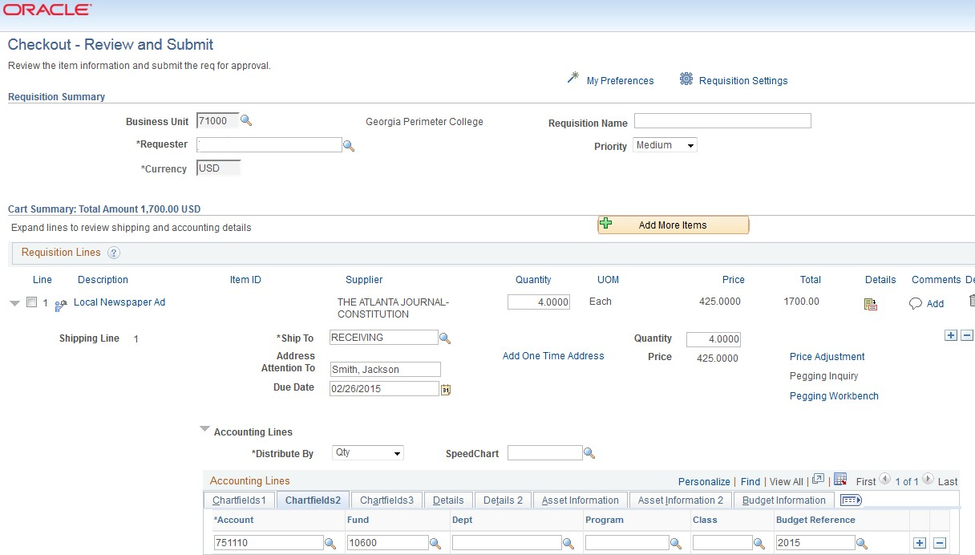

How To: Charge Multiple Requisition Line Items to a Different Chartstring
- After you have added all Special Items to your requisition, go to the Checkout - Review and Submit page by clicking its link.
- Select the lines you wish to change distribution information for by placing a checkmark in their
select boxes.
- Select the Mass Change link.
- In the Accounting Information section, enter the new Chartfields and then click Apply.
- On the Distribution Change Options, to apply changes to all selected lines, select the option “All Distribution Lines” and click OK.
- Make any other necessary changes and then continue with the Special Request Requisition by selecting the Save for later button and Preview Approvals link.

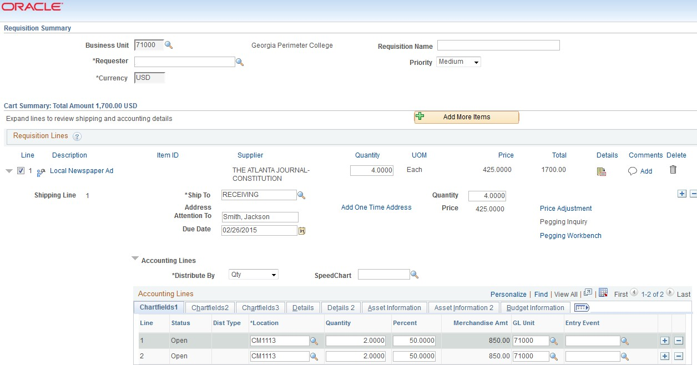

How To: Split Distribution for a Requisition Line
- After you have added all Special Items to your requisition, go to the Checkout - Review and Submit page by clicking its link.
- Expand the line by clicking on its Expand Section button.
- Choose whether to Distribute by Amount or Quantity through the drop down list.
- Locate the Accounting Lines section.
- At the end of the line under the Chartfields1 tab, click the Add a New Row button (+).
- If distributing by Quantity, continue. If distributing by Amount, go to step 7.
  - In the original distribution line, edit the quantity for the revised distribution.
  - Tab out of the Quantity field. The Percent field should adjust accordingly.
  - In the new distribution line, enter the quantity for the second Chartstring.
  - Tab out of the Quantity field. The Percent field will adjust accordingly.
  - Make the necessary changes to the second string of Chartfields on the Chartfields 1, Chartfields 2, and Chartfields 3 tabs.
- If distributing by Amount, continue. Otherwise, go to step 8.
  - In the original distribution line, edit the amount for the revised distribution.
  - Tab out of the Amount field. The Percent field should adjust accordingly.
  - In the new distribution line, enter the amount for the second Chartstring.
  - Tab out of the Amount field. The Percent field will adjust accordingly.
  - Make the necessary changes to the second string of Chartfields on the Chartfields 1, Chartfields 2, and Chartfields 3 tabs.
- Make any other necessary changes and then continue with the Marketplace Requisition by selecting the Save for Later button and Preview Approvals link.

How To: Manage Requisitions
- In PeopleSoft Financials Core system, select eProcurement in the menu.
- Select Manage Requisitions.
- Enter search criteria for your requisitions.
- Click the Search button.
- To see a requisition’s lifespan, click its expand button.
- To see details about an active or completed stage in the lifespan, click on the lifespan icon.
- To see the approval path for a requisition, click on the Approvals lifespan icon.
- To see requisition line information, click on the line description.
- To see requisition schedule and distribution information, click on the Requisition lifespan icon and then select the Requisition and Schedule Information link.
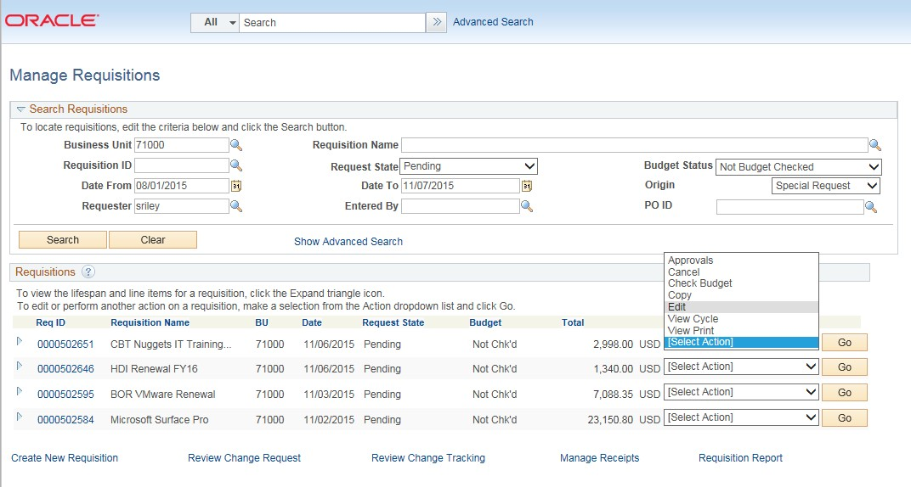

How To: Edit a Requisition
- In PeopleSoft Financials Core system, select eProcurement in the menu.
- Select Manage Requisitions.
- In the search field, enter the Requisition ID that needs to be edited (you may need to clear some of the search fields).
- Click the Search button.
- In the Requisition ID’s action drop-down list, select Edit Requisition.
- Click the Go button.
- To update the requisition line information, select the link under Description. Make the necessary changes and the return to 3. Review and Submit.
- To update an individual requisition line Chartfield information, click its expand button. Make the necessary changes.
- To update multiple requisition lines at one time, select the lines to be edited and the select the
Mass Change link. Make the necessary edits.
- Select the Save for Later, then the Preview Approvals buttons.
- If reinitiating the approval process, consider adding a comment to inform your approvers of this.
- Insert any ad hoc approvers if necessary.
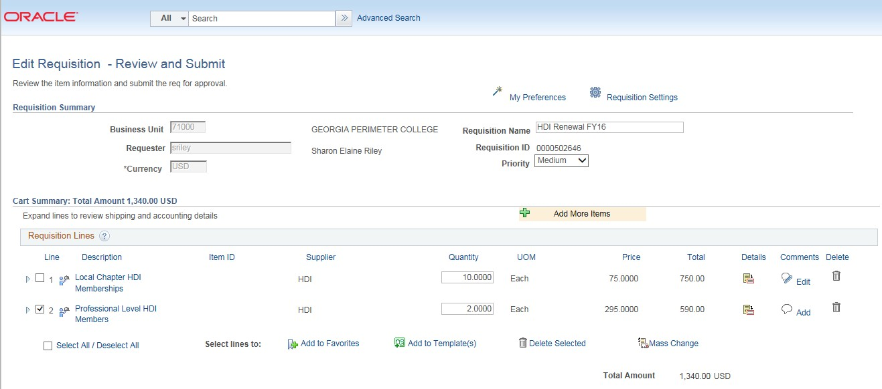

How To: Delete a Requisition Line
- From the PeopleSoft Financials Core system, select eProcurement in the menu.
- Select Manage Requisitions.
- Enter the Requisition ID in the Search Criteria (you may need to clear some of the search fields).
- Click the Search button.
- In the Requisition ID’s action drop-down list, select Edit Requisition.
- Click the Go button.
- Select the line(s) you want to delete.
- Click the Delete button.
- To confirm the deletion, click the OK button.
- Click the Save and Submit button.

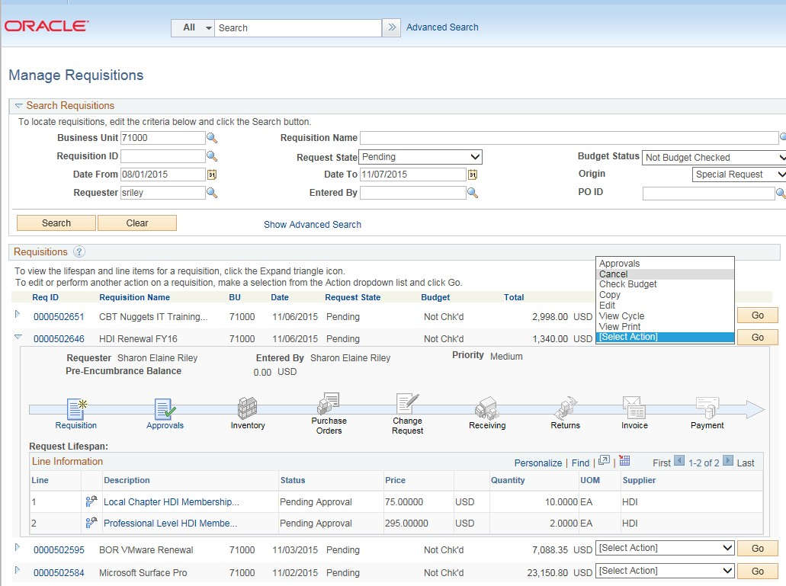

How To: Cancel a Requisition
- From the PeopleSoft Financials Core system, select eProcurement in the menu.
- Select Manage Requisitions.
- Enter the Requisition ID in the Search Criteria (you may need to clear some of the search fields).
- Click the Search button.
- In the Requisition ID’s action drop-down list, select Cancel Requisition.
- Click the Go button.
- On the Requisition Details page, select the Cancel Requisition button.
- On the Manage Requisitions page, the requisition status should change to Canceled.

How To: Create a Desktop Receipt
- Log into the PeopleSoft Core system.
- Select eProcurement in the menu.
- Select Receive Items in the menu.
- Location the Requisition Line Item you need to receive.
- Select the requisition by placing a checkmark in its Select box (or to receive all line items, choose the Check All button).
- Select the Receive Selected button.
- If needed, change the Received Date. By default, the current date will be listed.
- In the Received Qty field, enter the quantity received.
- To review details about the actual purchase order, select the Details… icon.
- To attach comments to the Receipt, select the Comments icon.
  - Here you can indicate the condition and input a comment if needed.
  - Do not include any slashes (/) in your comments.
- Click the Save Receipt button.
- Your Receipt Number will be listed on the “Receipt Saved Successfully” page.

If you have a Requisition line item that you previously received a partial quantity for, you will still be able to go back to this same page and receive additional quantities.
