Creating rank and promotion portfolios in OneDrive is quick and easy. We recommend that you use OneDrive online, but you can also do this from your desktop if you have OneDrive set up locally:

1. Starting in Outlook online, click the “waffle iron” (App Launcher) in the top left and select OneDrive.

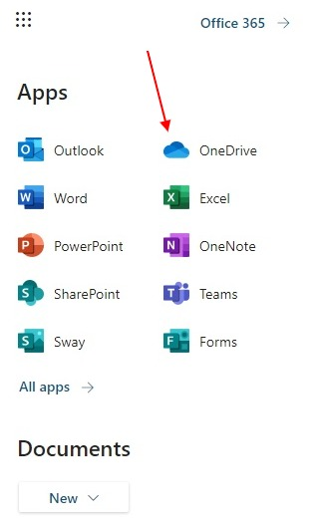

2. Create a new folder and label it “ePortfolio.”

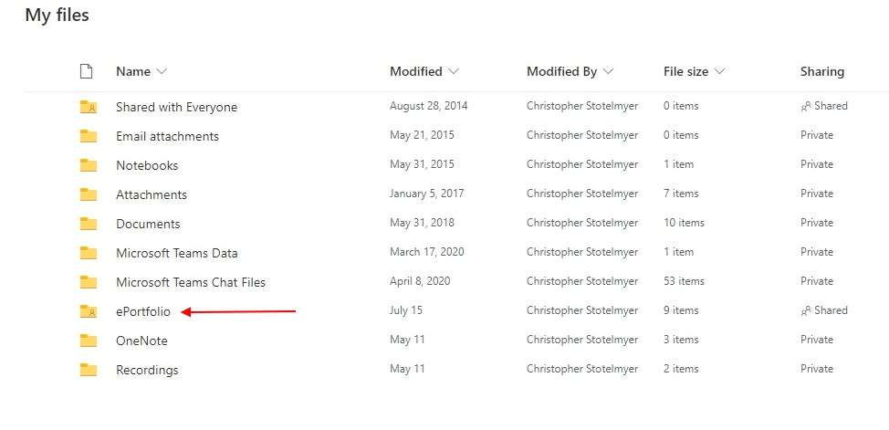

3. Open the “Portfolio” folder and create five new folders for each of the criteria from the Rank and Promotion Document. There are four documents that do not need a new folder.

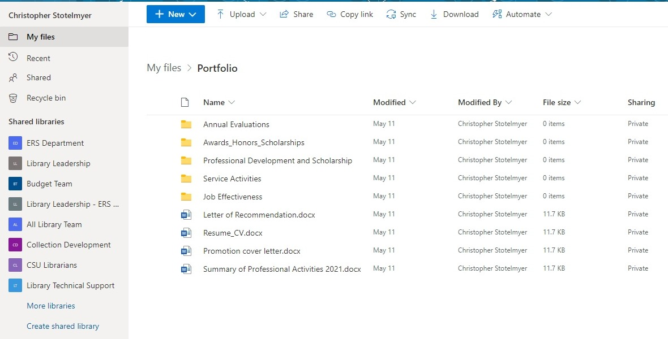

4. Place your promotion evidence in the proper folders.

5. Select the “Sharing” link for your ePortfolio to allow promotion committee members access to folders and items. Access privileges will be inherited by all the subfolders and documents in your ePortfolio

Step 1

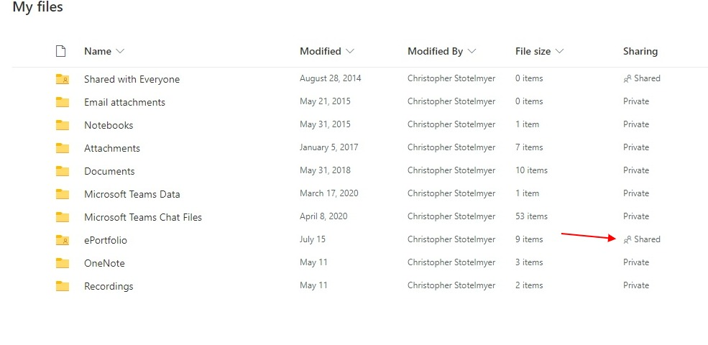

Step 2 (Note that you can give edit or viewing privileges – this is up to you)

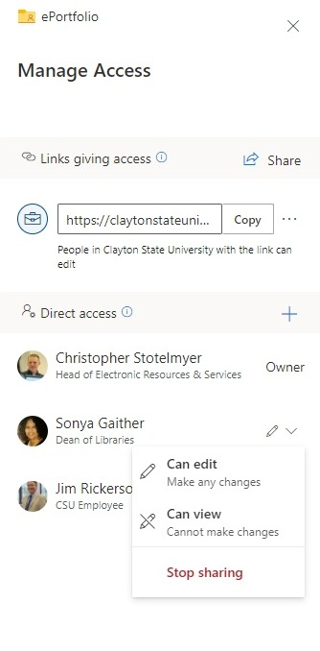

6. After you set access privileges you can also provide the committee with a link to the “ePortfolio” folder for convenience. Click the “Sharing” link again and copy the link provided:

