Faculty/Staff Guide to Digital Measures

ACTIVITY INSIGHT OVERVIEW

Activity Insight organizes and builds reports on teaching, research and service activities. It enables you to keep track of your activity information just once so that many outputs can be prepared, such as annual activity reports, promotion and tenure documents, accreditation reports, your CV, and more.
Activity Insight is easy to navigate. To help you get started, here is a quick overview of the utilities you will work with most often.

Left-Hand Menu
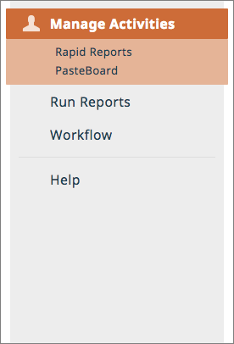
The left-hand menu of the system displays at least two main utilities, Manage Activities and Run Reports. You may have other utilities if your Digital Measures Administrator has given you security access to them.
Manage Activities: Add or update information about the activities you accomplish.
Run Reports: Run reports that have been custom- built for your campus.
Help: Submit suggestions on how to improve the system, questions about use of the system, or report system errors.

Manage Activities

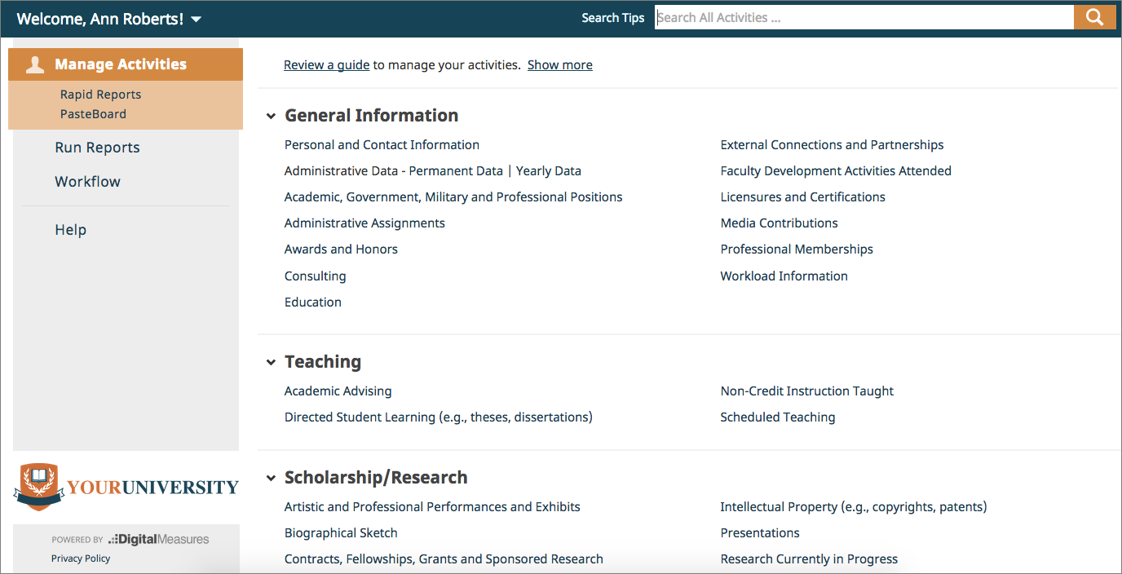

Overview

When you first visit this page, it would be good to spend a few minutes looking through the screens accessible from it. To access a screen, click its name. The resulting summary screen displays records that are stored for that screen. There are six possible actions you can take from the resulting screens. Note: not all of these actions will always be available.
To add a new record, select the button.
To import items in bulk, select the button (available only for the Intellectual Contributions screen).
To delete a record, select the appropriate check box, then select the button. To edit or view a record, click anywhere in the record row on the summary screen.
Note: Your Digital Measures Administrator may have added records to the system for you. These records can be viewed, but cannot be edited or deleted. A icon identifies these records. If revisions are needed to the records which have been entered on your behalf, contact your Digital Measures Administrator using the Help link.
To copy a record, select the appropriate check box, then select the button.

Saving Records

When working in the system, it is important that you preserve modifications by selecting one of the Save buttons at the top of the screen. If you attempt to navigate away from a screen containing unsaved changes, a warning message will display to determine whether you would like to return to the screen and save your modifications before proceeding.

Run Reports

This utility allows you to run custom built reports.
To run a report, simply select from the options available in the menu.

TIPS AND FEATURES

Take a look at the following key features that streamline data entry and reporting!

Expanding Text Boxes

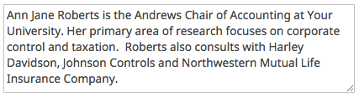You may see two diagonal lines in the bottom right corner of text boxes. Clicking this area and dragging allows you to resize the text box as needed.

PasteBoard

You will find the PasteBoard to be a time-saving feature. The PasteBoard allows you to copy text from another document (for example a Microsoft Word document), and paste it into the PasteBoard.
After you have pasted text into the PasteBoard, you can then select text from it, click-and-hold on the text you elected, and drag the it into a field in the system to have it pasted into the field.
To access the PasteBoard, click the text PasteBoard in the left-hand menu under Manage Activities.
The PasteBoard will appear in the bottom right-hand corner of your screen and can be dragged anywhere on the screen as needed. Text in the PasteBoard remains in the PasteBoard after logging out. This allows you to use this information during future sessions.

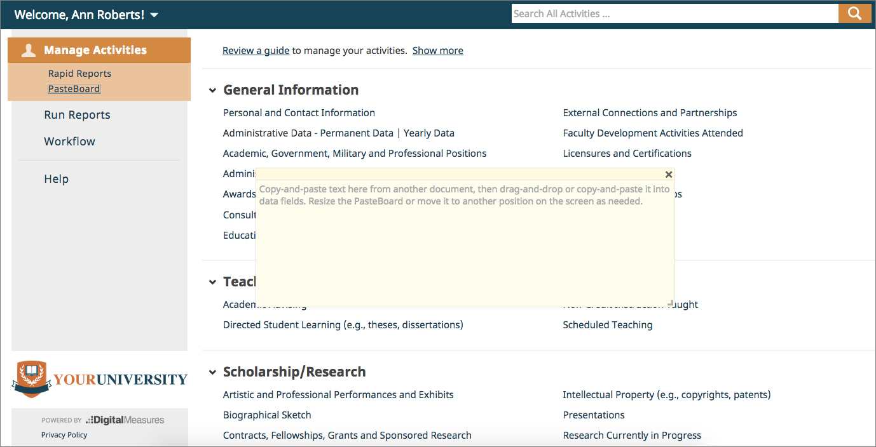

Rapid Reports

While you are managing your activities, you may want to see how a particular change looks on a report. Rapid Reports provides you with quick and easy access to the reports you can run from Activity Insight.

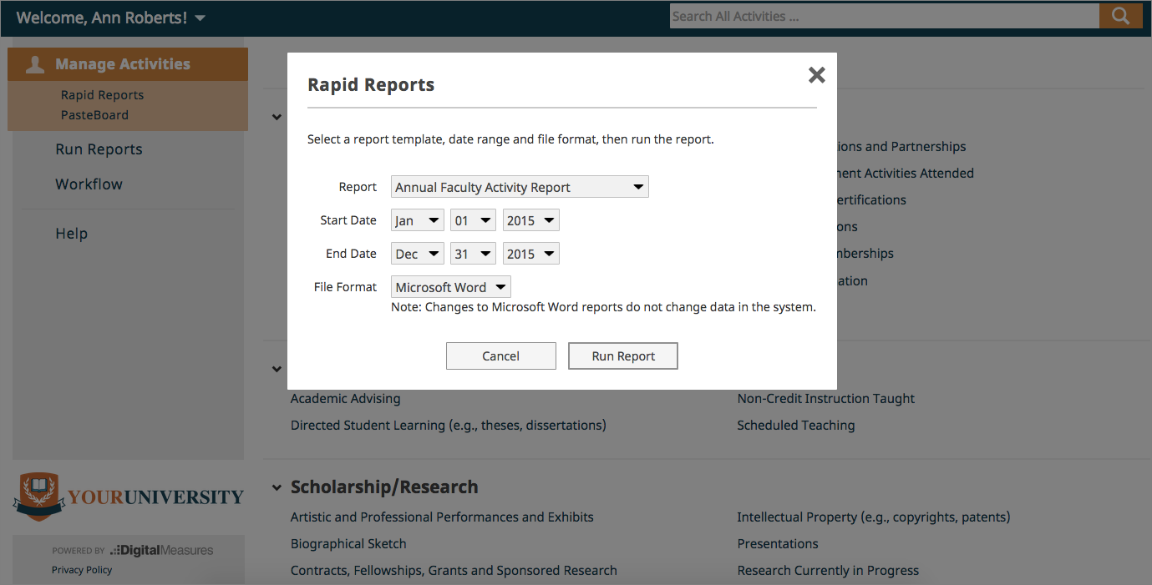

Source: https://www.digitalmeasures.com/activity-insight/docs/guide.html

