President’s Report
April 22, 2019
Faculty Senate

- Budget Two handouts include the budget statement sheet for the University of New State Appropriations, and an explanation of budget allocations, as well as salary administration. We are hopefully in the final year of share claims to formula funding, and are grateful for the inclusion of new state dollars for salary increases. The rules by which those increases, as noted, are explained in the second attachment. Many of these will be covered also at the campus open budget meeting.
- Conflicts of interest this issue arose from publicized work by USG Researcher and a group representing Pay Day Lenders. “April 16, 2019 Conflicts of Interest – Research and Institutional. The USG recognizes the benefits of collaboration and commercialization with the private sector and other third-party entities that supports the USG mission. The resulting relationships and agreements, however, must not undermine the public’s trust, compromise the integrity of the USG mission, or inappropriately influence teaching, research, and service activities. Under no circumstances should a grant, gift, contract or other funding be accepted that in any way limits the ability of USG employees to conduct or report the results of research in accordance with applicable scientific, medical, professional, and ethical standards. Institutions shall incorporate policy and review procedures within its institutional guidelines consistent with this policy.” As we develop such standards, we will be consulting with faculty senate and committee groups to implement our interpretation of this policy. We are confident that this policy will not alter what we would perceive our own institutional commitment to integrity.
- Commencement while graduation ceremonies for many of us are a part of the ordinary part of our academic year, they are often transformational events for a great number of our students and their families. Nearly 1/3 of our graduates are the first in the families to graduate from a college or university. And over many years, at these commencements, I have been reminded how much our students notice faculty members from whom students have learned. And so my thanks to the senate and other colleagues for attending these ceremonies. And certainly graduation still matters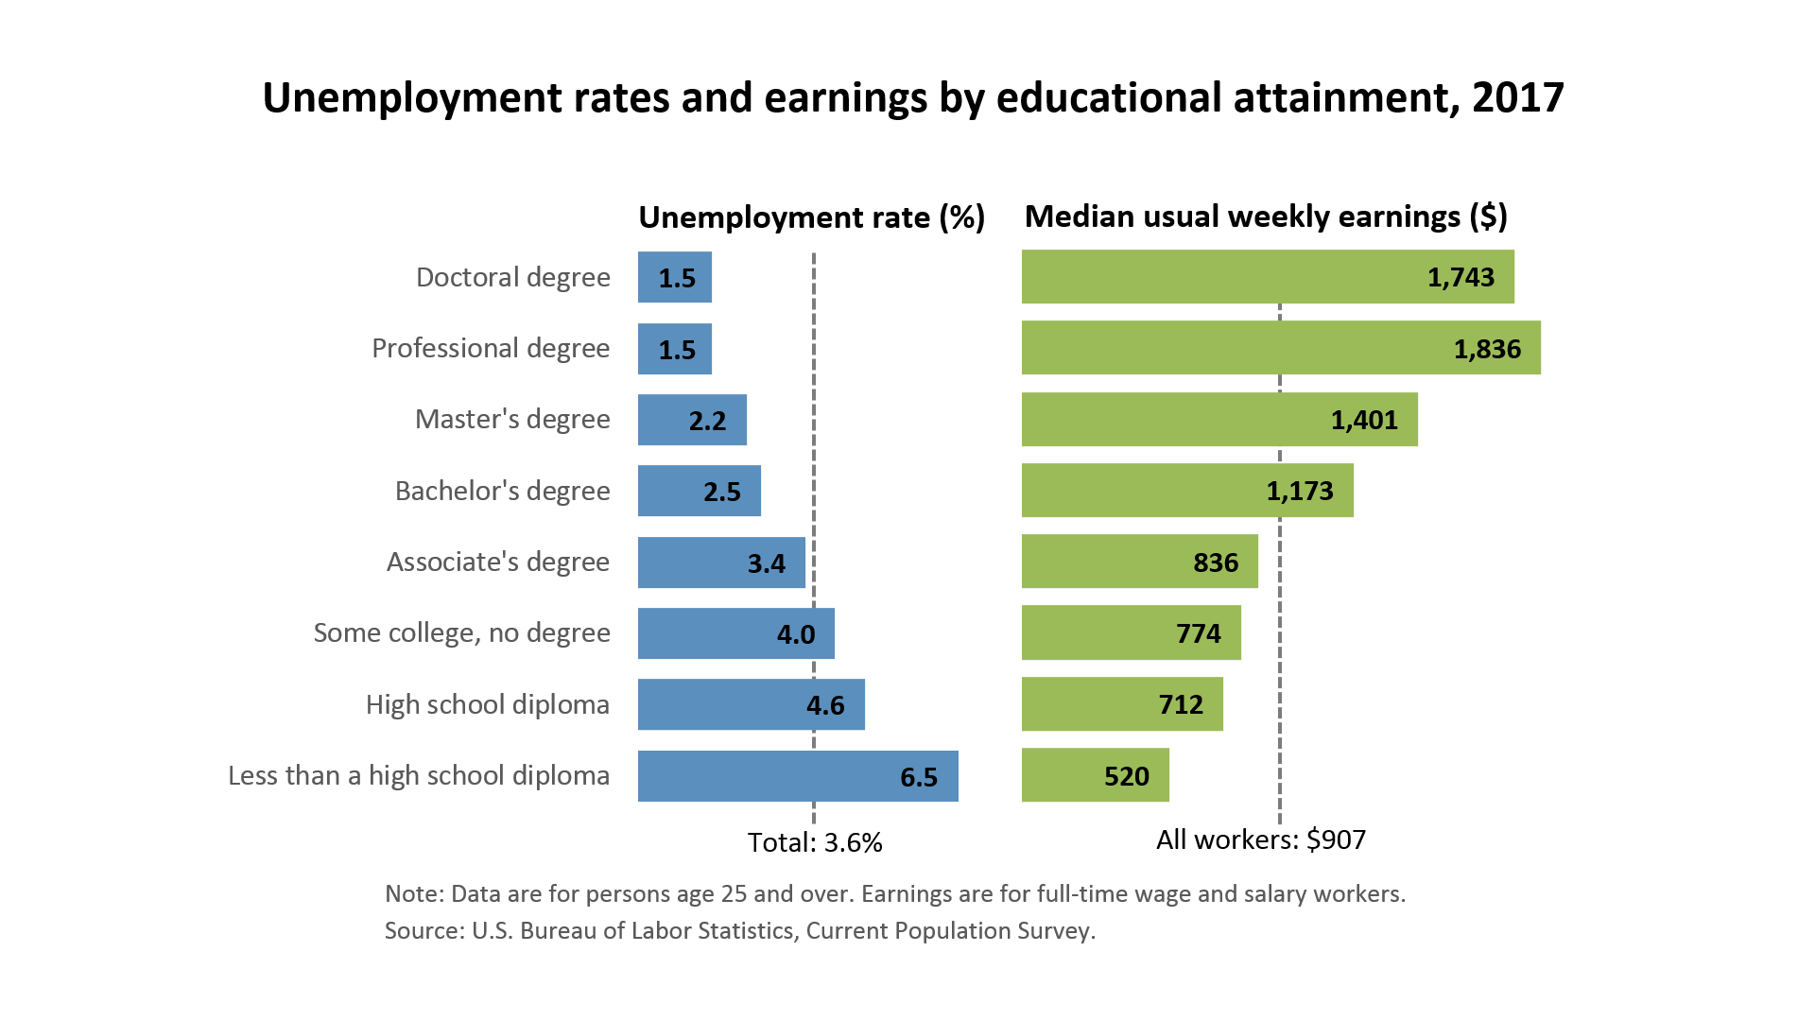
- Thanks and Questions

